IST 718 – Homework 2

Predicting Home Prices

1 Introduction 2

2 Analysis & Models 2

2.1 About the Data 2

2.2 Data Processing 2

2.3 Exploratory Data Analysis 2

2.4 Models 5

2.4.1 Model Training and Testing Strategy 5

2.4.2 Timeseries Modeling using prophet library 5

2.4.3 Timeseries Modeling Optimization 6

2.4.4 Final Models 7

3 Results 7

3.1.1 Forecast Comparison 7

4 Conclusions 8

4.1.1 What technique/algorithm/decision process did you use to downsample? 8

4.1.2 What three zip codes provide the best investment opportunity for the SREIT and Why? 9

4.2 Appendix – Bonus 9

Develop a geographic visualization that, in your view, best depicts the data and recommendation 9

# Introduction

Warren Buffet said Real estate is an asset “for a great many people,” particularly for families that plan on being in the same location for many years. “If you know you’re going to live in a given area or think it’s very likely, for a considerable period of time, and you’ve got a family, the home is terrific.”

We don’t have to emphasize how important a house plays in our life. In this analysis will use the past historical house prices to answer the business questions on where to invest for the Syracuse Real Estate Investment Trust (SREIT).

# Analysis & Models

## About the Data

We will be starting with the data set, collected and curated by Zillow for our analysis(<http://files.zillowstatic.com/research/public/Zip/Zip_Zhvi_SingleFamilyResidence.csv>)

The dataset has house prices by zip code from March 1996 to March 202, shown in Figure 1.

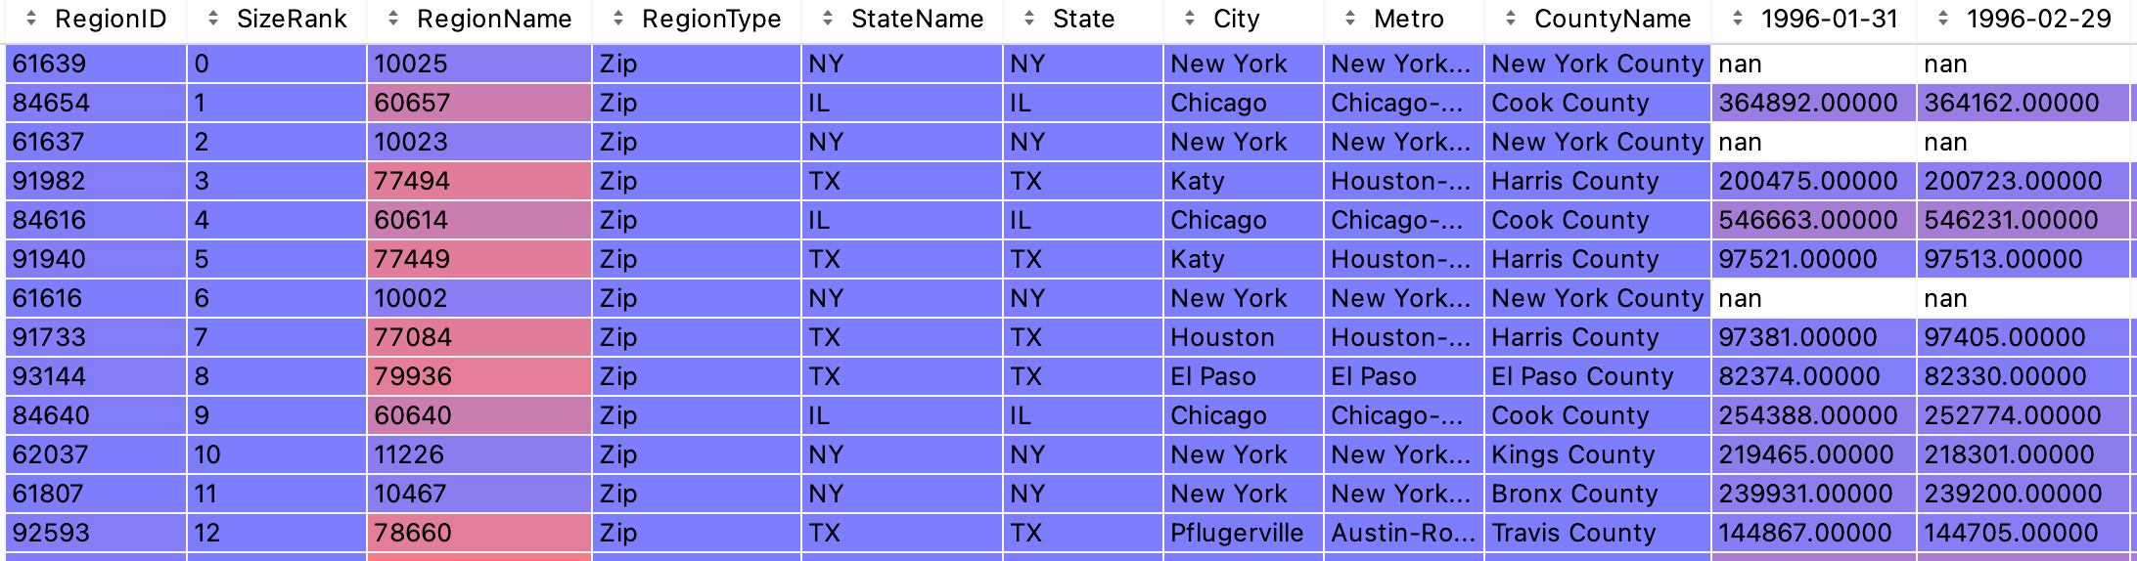

Figure

## Data Processing

We will convert this wide-format data into a long format where each column date will be converted to a row to do a time-series forecast.

## Exploratory Data Analysis

We will look at the trend of house prices in four metros in Arkansas, shown in Figure 2. All four metros dipped in the 2007 recession except Fayetteville. And the overall market started rebound starting 2016.

Figure

When we look at the percent of price change from 1997 to 2020, on average, the house prices increased by 100%; they doubled in value, and in some zip codes, 1500%, that’s a perfect investment opportunity.

Figure , Price change from 1996

Figure 4 & 5 Show the percent price change for the last five years from 2016. Northwest had an above-average growth, and it may be suited for our investment goals.

Figure , Price change from 2016

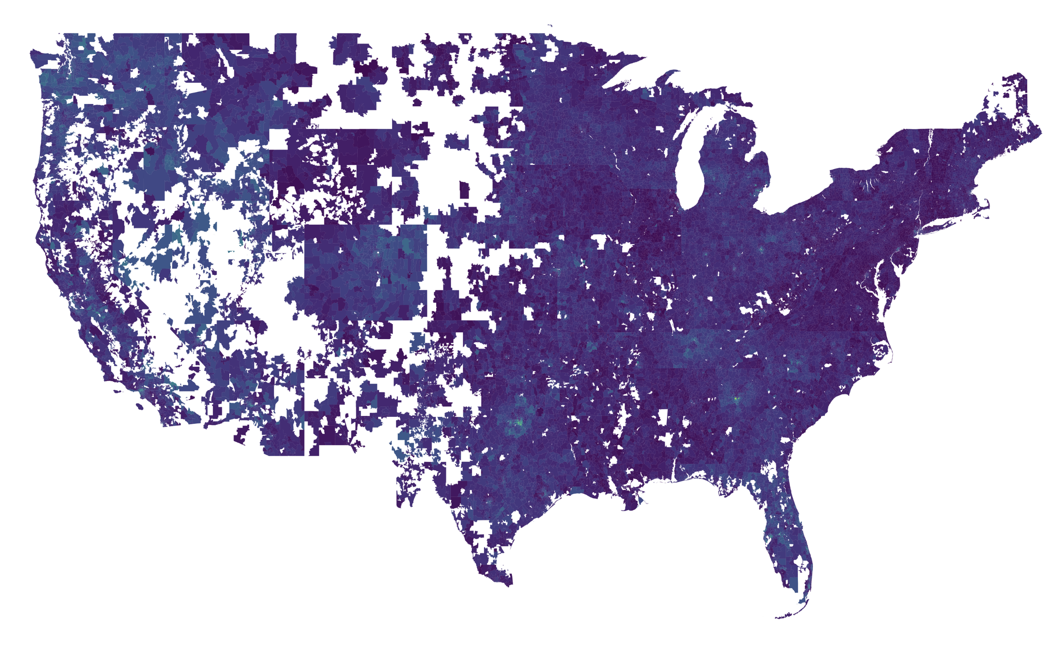



Figure , Price change from 2016

## Models

### Model Training and Testing Strategy

We will hold data for 2020 and beyond for our time series modeling to test our model accuracy. And we will train a model individually for each zip code since the data we had is zip code specific. So, we will train a total of 30464 models.

And for our time series, we will be using the prophet library. The prophet is a procedure for forecasting time series data based on an additive model where non-linear trends are fit with yearly, weekly, and daily seasonality, plus holiday effects. (Facebook Prophet, n.d.)

### Timeseries Modeling using prophet library

We selected a random zip and trained our initial model, which gave us the predictions shown in Figure 6. This model didn’t give us a good forecast since the model does not see the COVID19 trend.

Figure , training data until 2019

So, we will include all of our data set in our training, which resulted in better forecasting, as shown in Figure 7

Figure , with data until 2021 march

### Timeseries Modeling Optimization

Our model is amplifying the seasonality, not in our dataset.

Figure 8, shows the cross-validation of our model. The prediction error is at 1% for a month and 3% for a year out.

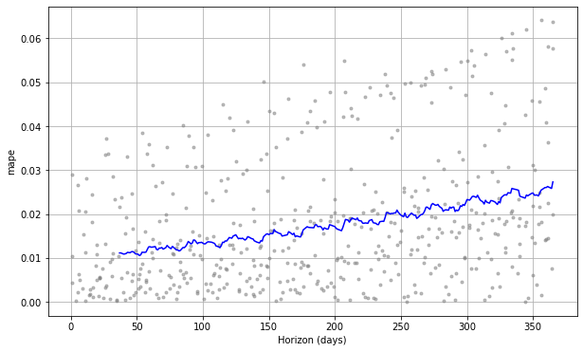

Figure

To tune the model, we will set up a grid search to tune the hyperparameters changepoint_prior_scale and seasonality_prior_scale. The optimal parameters we arrived at are

changepoint_prior_scale: 0.1, seasonality_prior_scale: 0.01. Figure 9, shows the final optimized model, which is a slight improvement over our previous model.

Figure , Final optimized Model

### Final Models

It’s time we set up a batch job to build the models for each of our zip codes. We used the python threading library to parallelize the model building on a 16 CPU/60Gb server. It took 4 hours to build all our models. The models saved on disk took around 60GB of space.

# Results

### Forecast Comparison

We compared the percent change in price from March 2020 to March 2021for the zip codes and tabulated the top and bottom 10 locations as shown in Table 1. If we must choose the top 3 zips to invest in, we can simply pick the top 3 locations from the table.

Given Syracuse is a Non-Profit Organization, what would be our best interest to invest in. Should we target college towns to improve student housing? Table 2, summarized the top 10 college towns by their percentage of price change in a year.

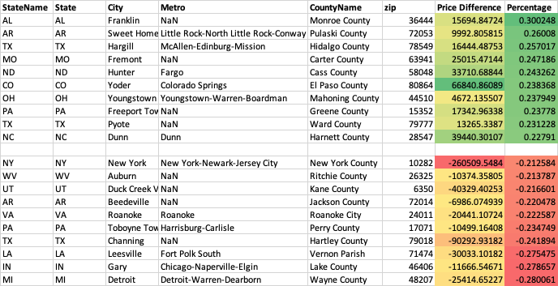

Table , top 10 and bottom ten zip’s by price change

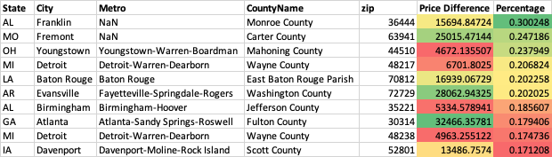

Table , Top 10 college towns

# Conclusions

We explored the time-series housing data to predict our best investment opportunities, below are our recommendations

### What technique/algorithm/decision process did you use to downsample?

We did not down-sample the data; we increased the compute power to process all data.

### What three zip codes provide the best investment opportunity for the SREIT, and Why?

We recommend the below two sets of options based purely on their value appreciation in a year. If we choose one, Franklin, Alabama, will be our top choice; it grew faster and is also a college town.

|  |  |  |  |
| --- | --- | --- | --- |
| Top Overall | | Top College Town | |
| AL | Franklin | AL | Franklin |
| MO | Fremont | AR | Sweet Home |
| OH | Youngstown | TX | Hargill |

## Appendix – Bonus

#### Develop a geographic visualization that in your view best depicts the data and recommendation

Figure 10 shows the average price increase we predicted by state and the top recommendations.

Figure , Price Predicted for 2021